

**Design and analysis of a Double Pulse Test PCB**

**ECE – 593 Project Report**

**Submitted to:**

**Dr. Mark J. Scott**

**Submitted by:**

**Tanzila Akter**

**Mirza Sanita Haque**

**Date: 28 April, 2022**

**List of Symbols**

|  |  |
| --- | --- |
| **Symbols** | **Abbreviation** |
| Eon | Energy loss during turn on event |
| Eoff | Energy loss during turn off event |
| Vds-off | Drain-source voltage during turn off |
| Vds-on | Drain-source voltage during turn on |
| Id-off | Drain current during turn off |
| Id-on | Drain current during turn on |
| tOFF | Turn off time |
| tON | Turn on time |
| tri | Drain current rise time |
| tfi | Drain current fall time |
| trv | Drain-source voltage rise time |
| tfv | Drain-source voltage fall time |
| vIN | Input voltage |
| iD | Drain current |
| L | Inductance |
| C | Capacitance |
| iOUT | Output Current |
| vOUT | Output Voltage |
| fs | Switching Frequency |
| RDS_ON | Turn on Resistance of MOSFET |
| VF | Forward Voltage |
| Qrr | Reverse Recovery Charge |
| D | Duty Cycle |
| IQ,rms | RMS Current Through MOSFET |
| Vd | Drain Voltage |
| η | Efficiency |
| Il, pp | Peak to Peak Inductor Current |
| Vc, pp | Peak to Peak Ripple Voltage |
| RTH-JA | Thermal Resistance, Junction-Ambient |
| RTH-SA | Thermal Resistance, Sink-Ambient |
| RTH-JC | Thermal Resistance, Junction -Case |
| RCS | Thermal Resistance, Case-Sink |
| TS | Sink Temperature |
| TA | Ambient Temperature |
| Vds | Drain-Source Voltage |
| Vgs | Gate-Source Voltage |

**Introduction:**

The common scenario for every power equipment is experiencing switching losses.  However, by optimizing and rigorously measuring design factors linked to power efficiency, these losses may be reduced. The double-pulse-test (DPT) technique is the recommended approach for measuring the switching parameters of MOSFETs or IGBTs. It is performed to ensure that the mentioned power device specifications are accurate. It also validates the real value and the discrepancies inside the power devices.  Engineers may completely assess the dynamic behaviors of power devices under a variety of scenarios by examining turn-on, turn-off, and reverse-recovery characteristics, whether to improve devices or check the true value or deviation of power devices and modules.

The double pulse test PCB provides safer and faster measurements under controlled conditions when compared to similar kinds of testing in a final converter design, where, for example, the junction temperature is difficult to manage. With this board, different types of converters e.g., buck converter, boost converter, buck-boost converter, and half-bridge inverter configurations can be achieved. These configurations can be useful applications like step-up, step-down, DC to AC conversion, synchronous rectification, switching amplification, etc.

**Background:**

***Safety:***

1. There should be a common ground to avoid ground loop problems of the oscilloscope.
2. Switching pulses should be 180 degrees out of phase. Otherwise, both switches will turn on at the same instant which will damage the circuit.
3. Proper grounding should be provided for instrumentation. Make sure the module mounting plate and enclosure metal structure or surfaces have a good low impedance ground connection.
4. In case of high voltage e.g. 350 V, equipment should not be touched to avoid huge shock.
5. To restrict the fault energy in the event of a module failure, make sure the high voltage DC supply has a current limiting function.
6. DC power supply should be closely monitored so that the model doesn’t switch between constant voltage mode to constant current mode.
7. A test enclosure like glass shield can be useful for protection against accidental contact with high-voltage circuits and acts as a physical barrier in the case of a severe failure.

***Purpose and Principles:***

Double pulse is a test method for evaluating the dynamic behaviors of power devices and measuring their switching parameters to calculate the total energy loss in the switches. The energy loss calculations can be a trade-off in the measurement of efficiency, component size, and electromagnetic interference of the designed configuration, for example, buck converter. The following switching parameters are measured with a double pulse test:

* Turn-on parameters: td(on) : turn-on delay, tri: drain current rise time, tfv: drain-source voltage fall time.
* Turn-off parameters: td(off) turn-off delay, tfi: drain current rise time, trv: drain-source voltage fall time.

The energy loss during turn on and turn off event of a switch can be calculated from the following equations,

Eon = ½ * Vds-off* Id-on * ton ………………………………………………………………..…… (1)

Eoff = ½ * Vds-on* Id-off * toff ….…………………………………………………………..…….. (2)

|  |  |
| --- | --- |
|  |  |

Figure 1: Double Pulse Test Schematic Figure 2: Switching Waveform

Two voltage pulses with varying pulse widths are required for the double-pulse test. A double pulse test circuit is used to verify the output of this project.

**Theory of Operation:**

***Galvanic Isolation:***

Galvanic isolation prevents current flow by isolating functional parts of electrical circuits. It is important for two most common reasons, and they are safe from fault conditions and wired communication between devices where each device regulates its own power. Components used to create isolation in this project are mentioned as U5 and U8.

|  |  |
| --- | --- |
| **Table 1: Typical Characteristics of ISO7710D** | |
| Voltage - Isolation | 3000Vrms |
| Common Mode Transient Immunity (Min) | 85kV/µs |
| Voltage - Supply | 2.25V ~ 5.5V |
| Operating Temperature | -55°C ~ 125°C |

|  |  |
| --- | --- |
|  |  |

Figure 3: General Isolator Figure 4: Circuit Connection with Pin Diagram

One common method to create galvanic isolation is the use of a series capacitor. Here C12 and C13 are used to create galvanic isolation. The controlled signal output from the U5 isolator maintains a constant 12V input voltage for the low side gate driver to turn on. Moreover, U5 is used for the upper circuit connection of this PCB, and U8 is used to isolate the lower side of the PCB. The function of both isolators is the same. Galvanic isolation is important otherwise fluctuation of voltage may cause circuit damage.

GND: The ground plane on a PCB, or printed circuit board, is typically a large piece of metal that is connected to the energy supply potential or mutual attachment, also known as ground. This unique architecture aids in voltage transfer, signal restoration, and other functions. Furthermore, the ground plane effectively deducts disturbances and prevents undesirable interference problems.

The PCB ground plane is the large area of the printed circuit board that is normally made of metal and connected to the circuit ground. No fixed structure exists in this area. Rather, it is completely dependent on the layout's requirements.

UCOM: The input voltage of UCOM is 12V and UCOM is connected to U6 (Lower side gate driver). UCOM is connected to J4 and to turn the gate drive circuit on. UCOM is used in the upper circuit of the PCB.

LCOM: The input voltage of LCOM is 12V and LCOM is connected to U8 (Lower side gate driver). LCOM is connected to J3 and to turn the gate drive circuit on. LCOM is used in the upper circuit of the PCB.

U1 and U2: U1 and U2 are isolated module DC-DC converters. Here used a buck converter for this PCB operation. Input voltage is 5V for both U1 and U2. U1 is for the upper circuit and U2 is for the lower circuit. DC-DC converters are commonly used to efficiently generate a regulated voltage from a source that may or may not be properly controlled to a variable load. These converters are high-frequency power conversion circuits that smooth out switching noise into regulated DC voltages using high-frequency switching and inductors, transformers, and capacitors. Here used U1 and U2 to regulate voltage.

|  |  |
| --- | --- |
| **Table 2: Typical Characteristics of PDS1-S5-S12-M-TR** | |
| **Voltage - Input (Max)** | 5.5V |
| **Current - Output (Max)** | 83mA |
| **Voltage - Isolation** | 1.5 kV |
| **Operating Temperature** | -40°C ~ 105°C (With Derating) |

|  |  |
| --- | --- |
|  |  |
|  |

Figure 5: DC-DC Converter Figure 6: Circuit Diagram with Pin Configuration

U3: U3 is a linear regulator. In this project, the input voltage of this linear regulator is 5V and the output voltage is 3.6V. This 3.6V input is used to turn U4 for the upper circuit and U7 for the lower circuit operation.

|  |  |
| --- | --- |
| **Table 3: Typical Characteristics of LDK220M36R** | |
| **Voltage - Input (Max)** | 13.2V |
| **Current - Output (Max)** | 200mA |
| **PSRR** | 55dB ~ 50dB (120Hz ~ 10kHz) |
| **Operating Temperature** | -40°C ~ 125°C |

|  |  |
| --- | --- |
|  |  |

Figure 7: Linear Regulator Figure 8: Circuit Diagram with Pin Configuration

U4 and U7: The 74LVC1G14 is a Schmitt-trigger inverter with a single input and a standard push-pull output. U4 is the input to the isolator U5 and U7 is the input to the isolator U8. PWM input is given to these integrated circuits. The device requires a power supply ranging from 1.65V to 5.5V to operate. This device can be utilized in a mixed voltage environment because the inputs are tolerant to 5.5V.

|  |  |
| --- | --- |
| **Table 4: Typical Characteristics of 74LVC1G14W5-7** | |
| **Voltage - Supply** | 1.65V ~ 5.5V |
| **Current - Quiescent (Max)** | 200 µA |
| **Current - Output High, Low** | 32mA, 32mA |
| **Operating Temperature** | -40°C ~ 125°C |

|  |  |
| --- | --- |
|  |  |
|  |

Figure 9: Integrated Circuit Figure 10: Circuit Diagram with Pin Configuration

U6, U9: These are low-side gate drivers. This device offers a superior replacement for NPN and PNP discrete solutions. It can source and sink high, peak current pulses into capacitive loads. It is used in switched-mode power supplies, DC-DC converters, etc.

|  |  |
| --- | --- |
| **Table 5: Typical Characteristics of UCC27518DBVR** | |
| **Voltage - Supply** | 4.5V ~ 18V |
| **Operating Temperature** | -40°C ~ 140°C (TJ) |

|  |  |
| --- | --- |
|  |  |
|  |

Figure 11: Low Side Gate Drive Figure 12: Circuit Diagram with Pin Configuration

**Analysis:**

***Double Pulse Test:***

* ***Pulse width measurement:***

**Case 1:** Test condition: vIN = 25V, iD = 5A, L = 370 µH

The pulse width for this test can be measured from the following equation,

                            t(5A) = iD * L*Vin …………………………………………………...…………(3)

                             t(5A) = 5 * 370*10-6*25 = 74 us

**Case 2:** When drain current, iD = 10A, the pulse width becomes,

                             t(10A) = 10 * 370*10-6*25 = 148 us

* ***Energy loss calculation:***

From datasheet, we get,

Therefore, from (1) and (2), Energy loss during turn-on of MOSFETs comes out to be,

Eon = ½ * Vds-off* Id-on * ton

       = ½ * 400 * 4.8 *10*10-9

       = 9.6 µJ

Eoff  = ½ * Vds-on* Id-off * toff

       = ½ * 400 * 4.8 *9*10-9

       = 8.64 µJ

***Buck operation:***

For buck operation, let us consider the following case:

vIN = 10V, iOUT = 2A, D = 0.6, fs = 25kHz, L = 370µH

Datasheet values for MOSFET IPD60R380C6 (used in this project):

RDS_ON = 0.34 ohms, tON = 25ns, tOFF = 119ns, VF = 0.9V, Qrr = 3.3µC

* ***Efficiency calculation:***

Loss for Q1:

Conduction loss, Pcond,Q1 = IQ,rms2 * RDS_ON ……………………………………………………..(4)

                                         =  2* RDS_ON

=  2* RDS_ON

                                         = ()2 * 0.34

                                             = 0.822 W

Switching loss for Q1, PQ1,sw = (EON+EOFF) * fs ………………………………………….…… (5)

                                                   = ½ * (Vds-off * Id-on * ton + Vds-on * Id-off * toff) * fs

                                                   = ½ * (10*1.676*25*10-9 + 10*2.324*119*10-9) * 25*103

                                                   = 0.0398 W

Total power loss in Q1, PTOT,Q1 = Pcond,Q1 + PQ1,sw ………………………………………………(6)

                                                      = 0.822+0.0398 W

= 0.862 W

Loss for Q2, body diode:

Conduction loss, Pcond,Q2 = ID,AVG * VF ……………………………………………………… (7)

                                             = (D*Iout)*VF

                                             = (0.6*2 )* 0.9

                                             = 1.08 W

Switching loss for Q2, PQ2,sw = Vd * Qrr * fs ……………………………………………………. (8)

                                               = 10 * 3.3*10-6 * 25*103

                                               = 0.825 W

From equation (6),

Total power loss in Q2, PTOT,Q2 = Pcond,Q2 + PQ2,sw

                                                      = 1.08+0.825 W

                                                      = 1.905 W

Therefore, Total power loss in power device, PTOT = PTOT,Q1+ PTOT,Q2

                                                                                    = 0.862 + 1.905 W

                                                                                    = 2.7668 W

Efficiency of the buck converter, η = ………………………………….…...(9)

                                                         =

                                                         = = 81.3%

* ***Capacitor voltage ripple calculation:***

Voltage ripple of the output capacitor (220 µF) is,

………………………………………………………….…… (10)

           =

= 5.89 mV

* ***Junction temperature calculation without heatsink:***

For measuring the junction temperature of the two power devices when a heatsink is not used, let us assume that the ambient temperature, TA = 25 degree C,

From previous calculation,

PTOT,Q1 = 0.862 W ,  PTOT,Q2 = 1.905 W  and

Thermal resistance, junction-ambient temperature = 35 °C/W

TQ1-J = PTOT,Q1 * RTH-JA + TA ………………………………………..……………..….. (11)

           = 0.862 W * 35 °C/W + 25

           = 55.17 °C

TQ2-J = PTOT,Q2 * RTH-JA + TA …………..……………………………………………… (12)

           = 1.905 W * 35 °C/W + 25

           = 91.675 °C

* ***Thermal impedance calculation for a single heatsinks:***

For determining thermal impedance required from a single heatsink so that junction temperature of power MOSFET stays below 85 degrees C, let us assume,

TA = 30 °C , RCS = 1 °C/W

From datasheet,

The equation for sink temperature is,

TS = TA + (PQ1 + PQ2) * RTH,SA …………………………………………………...…… (13)

As MOSFET 2 has higher loss, let us find the sink temperature Ts from equation (13),

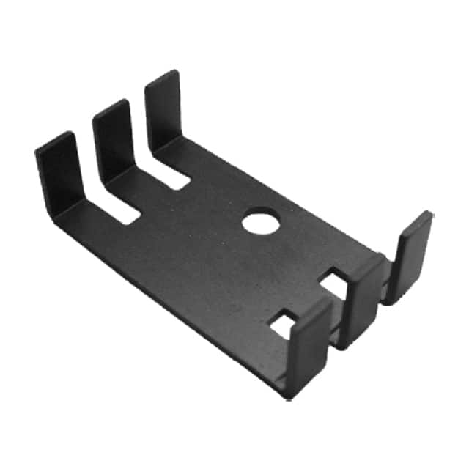Plugging this Ts to equation (13), we get,

86.9125 = 30 + 2.7668 * RTH,SA

RTH,SA =  20.57 °C/W

Figure 13: ATS-PCB1016 heat sink

To deal with this thermal resistance, sink-ambient, we can use Digi key part number ATS-PCB1016 . This is a rectangular thermal - heatsink consisting of pin fins of 9.35 mm in height. It can provide up to 20.60 °C/W of thermal resistance at natural airflow.

**Presentation of Experimental Results:**

***Double Pulse Test:***

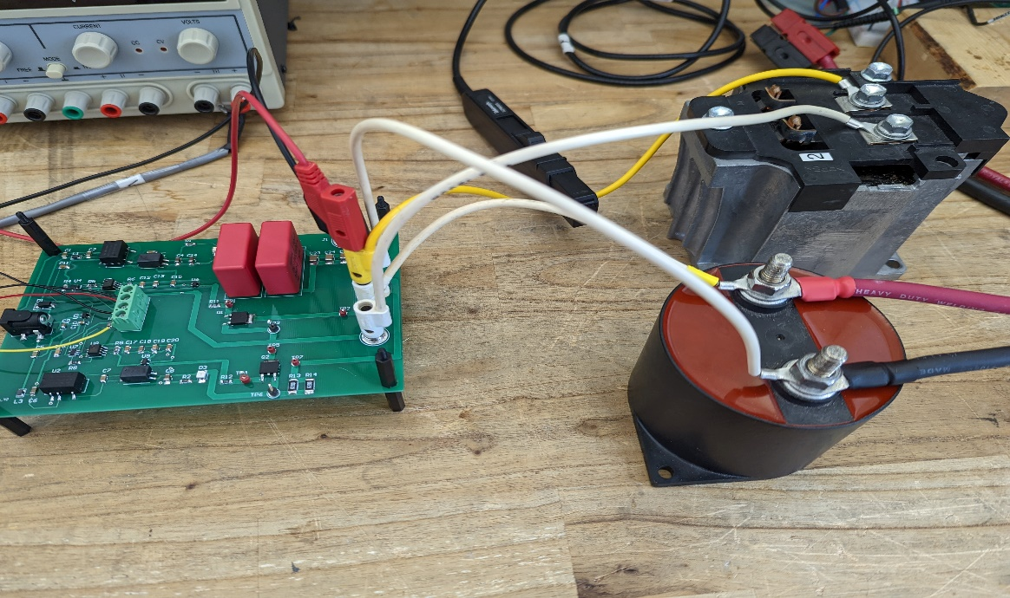

Figure 14: Double Pulse Test Setup

For doing the double pulse test, our power connections are as follows,

1. We used Q1 as the high side and Q2 as the low side power MOSFET.
2. The gate resistor was soldered to be 0.1 ohms.
3. Connected 370µH inductor between J4 (HVDC+) and J3 (Junction beween the MOSFETs).
4. DC source for the power supply was used between J4(HVDC+) and J2(HVDC-).
5. The 220 µF capacitor was connected in parallel to the DC power source.
6. The PWM comes from the DSP board which was run with code studio.
7. Oscilloscope channels were connected as mentioned in the table.

|  |  |  |  |
| --- | --- | --- | --- |
| **Table 6: Oscilloscope Connection with the Test Points** | | | |
| **Oscilloscope channel** | **First point** | **Second point** | **Result** |
| 1 | TP4 | TP6 | Shows the input voltage to the MOSFET, Vgs. |
| 2 | TP5 | TP6 | Shows Drain-Source voltage, Vds |
| 3 | TP7 | TP6 | Shows drain current Id |
| 4 | Through galvanic current sensor | | Shows inductor current Il |

For this setup, our switching waveforms came out as the following picture,

Figure 15: Switching waveform for double pulse test

Test conditions:

**Case 1:**  vIN = 25V, iD = 5A,  L = 370 µH

We considered the following parameters for the turn-on and turn-off events:

|  |  |
| --- | --- |
| **Table 7: Parameters for Turn-on and Turn-off Events** | |
| **Turn-on event parameters** | **Turn-off event parameters** |
| td(on) | td(off) |
| tri | tfi |
| tfv | trv |

For measuring the drain-source voltage rise time, we set the cursor from 10% of Vgs to 90% of Vgs in the rising edge of Vds. The time interval between the two cursors gives us the trv. By setting up the cursor in the same manner in the falling edge of the Vds curve, we get tfv. In the same way, we get the tri and tfi by setting cursor to the drain current curve.

Figure 16: Drain-Source voltage rise time, iD= 5A

Figure 17: Drain-Source voltage fall time, iD = 5A

Figure 18: Drain current rise time, iD = 5A

Figure 19: Drain current fall time, iD = 5A

**Case 2:**  Input voltage, vIN = 25V, Drain current, iD = 10A, Inductance, L = 370 µH

Figure 20: Drain current rise time, iD = 10A

Figure 21: Drain current fall time, iD = 10A

Figure 22: Drain-Source voltage rise time, iD = 10A

Figure 23: Drain-Source voltage fall time, iD = 10A

* The measured parameters for both the cases are listed below:

|  |  |  |  |
| --- | --- | --- | --- |
| **Table 8: Time Measurement for Vds=25V, iD =5A** | | | |
| tri | tfv | tfi | trv |
| 0.014us | 0.323us | 0.005us | 0.2826us |

|  |  |  |  |
| --- | --- | --- | --- |
| **Table 9: Time Measurement for Vds=25V, iD =10A** | | | |
| tri | tfv | tfi | trv |
| 0.0175us | 0.372us | 0.0055us | 0.2875us |

* ***Inductance calculation from experimental results:***

Difference between the minimum to the maximum value of the inductor current from Figure (15) is, di = 4.6A

Time difference to reach the peak of the inductor current, dt = 74 us

Therefore, L = = = 402 µH

* ***Energy loss calculation:***

**Case 1:** Measured value of Vds-off = Vds-on = 24V

Measured value of Id-on = Id-off = 4.6A

Rise time, tON = tri + tfv = 0.014 µs + 0.323 µs = 0.337 µs

Energy loss in turn on event, Eon = ½ * Vds-off * Id-on * tON

= ½ * 24 * 4.6 * 0.337*10-6

= 18.6 µJ

Fall time, tOFF = trv + tfi = 0.005 µs + 0.2826 µs = 0.2876 µs

Energy loss in turn off event, Eoff = ½ * Vds-on * Id-off * tOFF

= ½ * 24 * 4.6 * 0.2876*10-6

= 15.87 µJ

**Case 2:** Measured value of Vds-off = Vds-on = 24V

Measured value of Id-on = Id-off = 4.6A

Rise time, tON = tri + tfv = 0.0175 µs + 0.372 µs = 0.3895 µs

Energy loss in turn on event, Eon = ½ * Vds-off * Id-on * tON

= ½ * 24 * 2 * 0.3895*10-6

= 21.5 µJ

Fall time, tOFF = trv + tfi = 0.0055 µs + 0.2875 µs = 0.293 µs

Energy loss in turn on event, Eoff = ½ * Vds-on * Id-off * tOFF

= ½ * 24 * 4.6 * 0.293*10-6

= 16.17 µJ

***Buck Operation:***

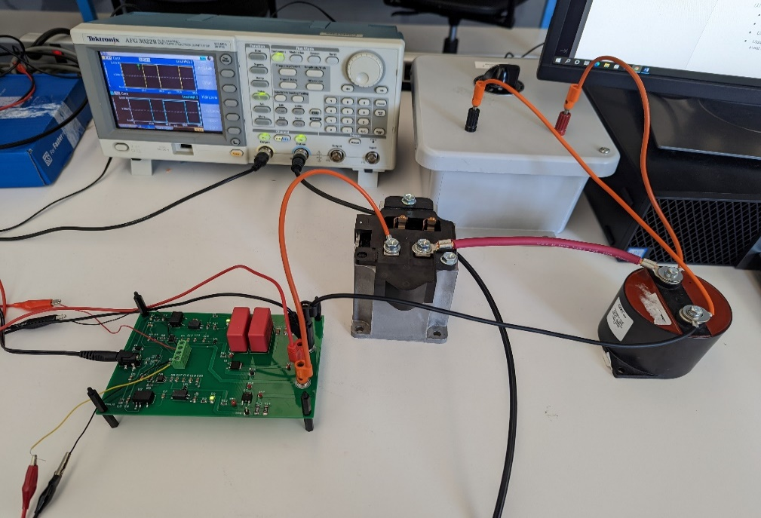

Figure 24: Buck operation setup

For doing the buck operation, our power connections are as follows,

1. We used Q1 as the MOSFET and Q2 as the body diode.
2. The gate resistor was soldered to be 0.1 ohms.
3. Connected one side of the 370µH inductor with J3 (MOSFET junction point) and another end with the capacitor to make a series connection between the junction of switches and the load.
4. DC source for the power supply was used between J4(HVDC+) and J2(HVDC-).
5. The 220 µF capacitor was connected in parallel to the resistor.
6. PWM input was given from the function generator.

|  |  |
| --- | --- |
| **Table 10: Parameters considered for buck operation** | |
| **Parameters** | **Values** |
| Input voltage, vIN | 10V |
| Output current, iOUT | 2A |
| Duty cycle, D | 0.6 |
| Switching frequency, fs | 25 kHz |
| Inductance, L | 370 µH |

|  |  |
| --- | --- |
| **Table 11: Measured parameters from buck operation** | |
| Parameters | Values |
| Input voltage, vIN | 10.09 V |
| Input current, iIN | 1.25 A |
| Output voltage, vOUT | 5.6 V |
| Output current, iOUT | 2.11 A |
| Inductor current, IL,PP | 5*50 = 250 mA |

From the above findings, the calculated inductor current comes out,

IL,pp,calculated = ………………………………………………..………………….. (14)

= = 242.16 mA

The input power, Pin = vIN * iIN = 10.09 * 1.25 = 12.6125 W

The output power, Pout = vOUT * iOUT = 5.6 * 2.11 = 11.816 W

* The efficiency of the buck converter is,

η = *100% = *100% = 93.68%

**Discussion:**

* Double Pulse Test
* From the datasheet, we can see the turn-on time is 10ns and the turn-off time is 9ns. Our experimental tON for case 1 was 337ns and tOFF was 287.6ns. For case 2, the turn-on time was 0.3895 us, and the turn-off time was 0.293 us. The time difference is introduced due to the large parasitic inductance of the board that results in a large time interval in the turn-on and turn-off events.
* In the analysis part, we got to turn on energy loss to be 9.6µJ and turn off energy loss to

be 8.64µJ. In the experiment, for case 1 the turn-on energy loss increases almost twofold

the analytical value. The values came out to be 18.6µJ and 15.87µJ for turn-on and turn-

off events respectively. For case 2, EON, EOFF is calculated at 21.5µJ and 16.17µJ

accordingly. For the above-mentioned reason, the energy loss deviates from the analysis.

* Buck Converter Test
* For theoretical efficiency calculation, we considered the switching losses that’s why the efficiency is calculated to be 81.3%. In the experiment we measured the input and output voltage and current. In this way, the efficiency comes out to be 93.68%. For the experimental result, we didn’t consider the switching losses. In addition, the output voltage was measured across the capacitor which gives us higher efficiency. The output voltage comes lower if measured across resistance because as per the experiment requirement, we needed to set output current to 2A. By doing so, load resistance become sufficiently lower to give wrong output voltage.
* Reflections

This project is the combination of the topics that are taught in the class and lab experiments. During the whole process, we learned how to design PCB with Altium designer software and how to do soldering which was something new for us. Moreover, we learned the switching characteristics and energy loss calculations of MOSFETs. With this project we can design different types of useful DC/DC topologies like, buck converter, boost converter, buck-boost converter etc. In addition, we can define switching parameters of MOSFETs by implementing double pulse test setup. To improve the performance of the project, the PCB could be designed efficiently meaning that we could use the top and bottom surface of the PCB to assemble the components. The MOSFETs could be placed closer to minimize the parasitic inductance.

**Conclusion:**

In this project, we designed a double pulse test board to measure the switching parameters of MOSFET. These parameters are essential for calculating the energy loss in the MOSFET switching events because the efficiency of different topologies e.g., the buck converter is dependent on how efficiently the switches shifts their connection during operating condition. To test the accuracy of this board, we made a buck converter using this board and got buck converter efficiency as 93.68%. The double pulse test is ideal for determining the loss of power devices. After all, there are a bunch of factors that can influence the real measurement from the data specification. Of course, it's worth learning while choosing gadgets. The more precise the design, the easier it is to keep costs under control.

**Datasheet:**

1. <https://www.mag-inc.com/Media/Magnetics/Datasheets/0P44022EC.pdf>
2. <http://web.mit.edu/6.131/www/document/3c90.pdf>
3. <http://ferroxcube.home.pl/prod/assets/e653227.pdf>
4. https://www.mag-inc.com/getattachment/Products/Ferrite-Cores/Ferrite-Shapes/Learn-More-about-Ferrite-Shapes/Magnetics-Ferrite-Catalog-2017.pdf